April 14th Features

**STATEMENT SHOES SHOOT**



**BOLD AND BEAUTIFUL**

**Tropical fruit, graphic flowers, full-blown frills: SS16’s statement shoes dazzle with every step.**

The gladiator sandal goes glossy thanks to Paul Andrew’s expert eye; this mid-calf pair has slim straps and come in rich purple leather.

Tabitha Simmons’ adorable buckled flats have a graphic, grown-up twist with colourful florals blossoming on the black.

The oversized, sculptural bows of Joshua Sanders’ cult sneakers are rendered ultra-pretty in blush broderie anglaise.

Trust Dorateymur to modernise the ladylike mule thanks to the block heel, squared toe and icy blue hue. THIS SHOE HAS BEEN SENT BACK TO THE DESIGNER SO WE’RE NOT STOCKING IT ANYMORE. REMOVE THE IMAGE AND TEXT

Coliac proposes scalloped trims and gleaming gold rings to replace the laces of boyish two-toned brogues.

The ones that got the front row excited: Proenza Schouler’s midi heels with metallic accents exemplify the duo’s signature cool-meets-elegant aesthetic.

Tabitha Simmons gives her towering sandals a further feminine flourish by smocking red and ecru linen into fabulous front frills.

Camilla Elphick’s suede stilettos are mouthwateringly sexy with watermelon slices playfully dotted across juicy orange straps.

**STATEMENT SHOES EMAIL INTRO**

SS16‘s Statement Shoes

Fall head over heels for this season’s standout styles: there’s

tropical fruit, graphic flowers, full-blown frills and many more dazzling details.

**FEMME FRESH: LEUR LOGETTE**

**Pretty, progressive classics**

Not a lot is known about Misako Imoto, the designer behind Leur Logette (the French name translates as ‘their little room’). This actually works in the Japanese label’s favour, however, leaving the ultra-feminine designs to speak for themselves. By diversifying the pretty details of traditionally romantic silhouettes (take the peplum jumpsuit, for instance, as well as back and shoulder cut-outs that let skin playfully peek through) then hand-finishing them on luxe fabrications, pieces are elevated with intriguing intimacy.

Scattered rose prints, antique lace inserts, tightly frilled trims and more take centre stage in Leur Logette’s Spring Summer 16 collection, where asymmetric accents dial down the girlishness. There are also more directional silhouettes to embrace too, like a camisole overlaid tank top that exemplifies the brand’s meticulous craftsmanship. Inspired by Parisian décor, with Japanese and vintage influences, no-one else is sewing up the delicate day-to-night dressing category quite so eclectically. Dressed up or down, worn at work or for a wedding: a little Leur Logette will go a long way, whatever the springtime occasion.

**Ancient Greek Sandals x Peter Pilotto**

**An unmissable collaboration**

Ancient Greek Sandals and Peter Pilotto’s collaboration this season does what the best partnerships do, complements through its contrasts. Taking gladiator sandals into tantalising new territory, the collection showcases the best of both brands’ distinctive aesthetics, and remains true to both. Ancient Greek Sandals founders Christina Martini and Nikolas Minoglou ensured their luxury leather sandals were timelessly handcrafted as usual but left the decorative details to Peter Pilotto and Christopher de Vos. And the innovative duo didn’t disappoint, keeping colours classic and updating them with the elegant-yet-experimental embellishments they’ve become renowned for. Here’s how to wear them.

**GO GRECIAN**

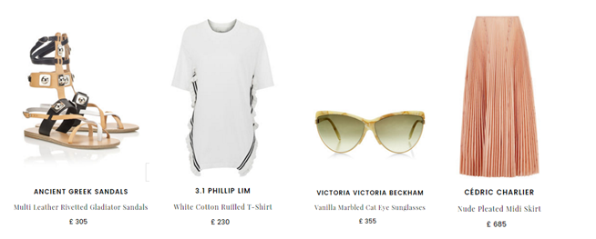

**Distinctive details – like these crisscrossing black, white and tan straps, Cedric Charlier’s sharp pleats and the ruffles running down 3.1.Phillip Lim’s T-shirt – transform a classic Grecian look.**

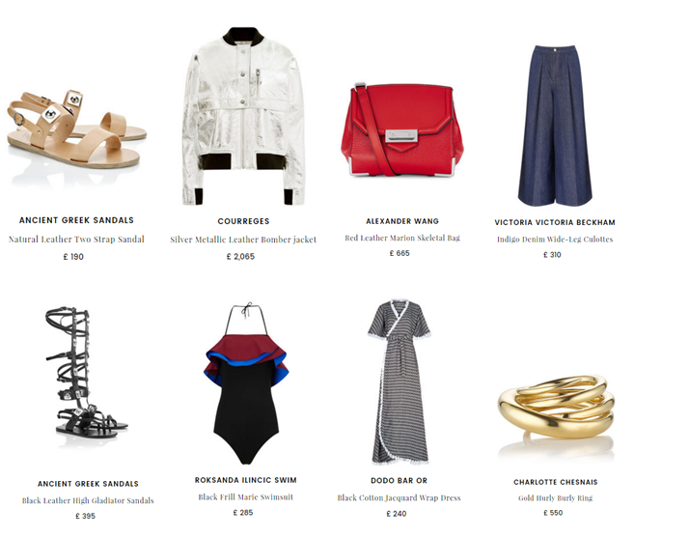**SILVER RUSH**

**To let the hardware really shine, pile on the silver. Courreges’ space age bomber and Alexander Wang’s bag accents should do the trick, tempered by Victoria, Victoria Beckham’s denim culottes.**

**BLACK MAGIC**

**Bring some serious fashion kudos poolside with this knee-high style; Roksanda’s frilled swimsuit and Dodo Bar Or’s monochrome cover-up inject just the right amount of old school glamour.**